NEMO
Neuro-Emotive Mobile Operator
Category: 5.3. Hardware Control Project Type: Autonomous Robotic System for Proactive Elderly Care
Mission: Bridging the gap between advanced AI and physical safety for the elderly.
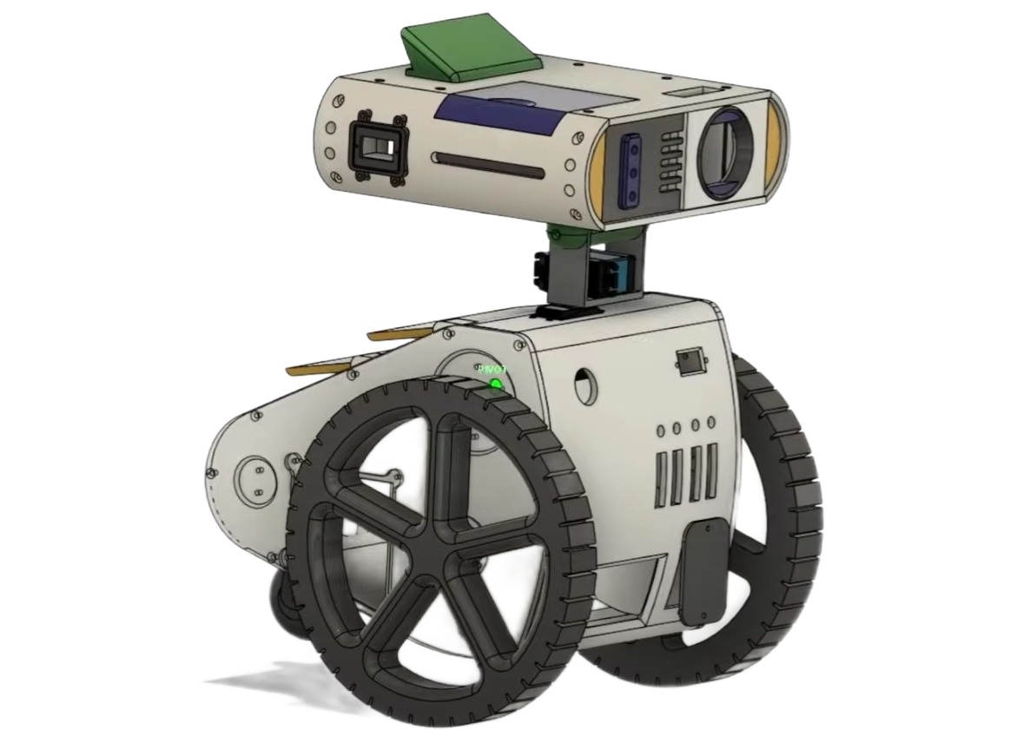
About the Project: NEMO is an autonomous robotic platform designed to provide a proactive safety net. Unlike passive systems, it utilizes Hybrid Cloud Intelligence to detect health emergencies and execute hardware-level rescue protocols via GSM and autonomous navigation.
Design Attribution: The aesthetic concept of NEMO is based on the original design from the film "The Lightning Code". The physical structure was independently engineered and adapted for real-world hardware integration by the project team.
Project Team:STEAM_VICTORY
MENTORS: Mukhtarov Timur
- Jahangir Aushakmanov - Lead Hardware Engineer & CAD Designer
- Alimbatyr Tursumbekov - Software Developer & AI Integration Specialist
Organization: Alimkhan Ermekov School-Lyceum City: Karaganda, Kazakhstan Year: 2026 12.02.2026

Project Title: NEMO (Neuro-Emotive Mobile Operator) Category: 5.3. Hardware Control Status: MVP (Phase 1: Hybrid Architecture)

1. ABSTRACT
NEMO is a modular autonomous robotic assistant designed to mitigate the risks associated with elderly people living alone. The project represents a technological shift from passive monitoring systems to proactive care. Utilizing a Hybrid Edge-Cloud Architecture, the robot functions as a mobile sensory node that combines the reliability of low-level hardware control (autonomous GSM emergency calls) with the computational power of Cloud AI (Gemini Vision) for health monitoring.
The current MVP demonstrates a robust telepresence system and safety protocols, including a multi-channel notification system (Telegram + GSM). The software architecture is built upon ROS 2 standards, laying the foundation for fully autonomous Lidar-based patrolling in the subsequent development phase.

2. PROBLEM STATEMENT & RELEVANCE
The global "Silver Economy" is currently facing a systemic crisis characterized by three factors:
- The "Long Lie" Syndrome: According to WHO data, 30% of individuals over 65 fall annually. Without immediate assistance during the "Golden Hour," survival and rehabilitation rates drop by 40%.
- Device Abandonment: Research indicates that 80% of seniors forget to wear panic buttons or smartwatches while at home, rendering passive safety systems ineffective.
- Social Isolation: Lack of regular interaction accelerates cognitive decline, contributing to conditions such as dementia and Alzheimer’s disease.
Proposed Solution: NEMO acts as a proactive agent that does not require the user to wear sensors. It physically navigates the environment, analyzes the context via computer vision, and executes hardware-level emergency protocols autonomously.
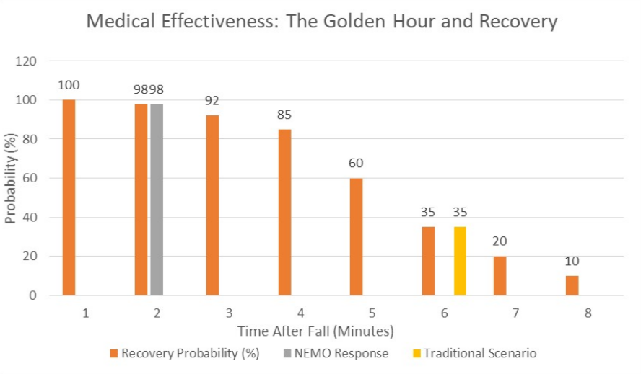

3. HARDWARE CONTROL ARCHITECTURE
The system is engineered on a Distributed Computing Model, separating high-level logic from real-time electromechanical actuation.

3.1. The "Brain" (High-Level Controller)
- Raspberry Pi 4 (2GB): Acts as the central gateway. To optimize costs and accessibility for the end-user, we utilize a "Thin Client" strategy. The RPi streams low-latency sensor data to the cloud via LiveKit, ensuring that complex multimodal analysis (Gemini AI) runs on high-performance servers without depleting the robot's onboard power.

3.2. The "Nervous System" (Low-Level Driver)
- Arduino Uno + CNC Shield: A dedicated real-time controller connected via Serial (USB). It is responsible for:
  - Actuation: Precision control of DC motors via PWM signals.
  - Safety Override: Direct hardware control over the GSM SIM Shield. Even in the event of a main operating system failure, the Arduino can trigger a physical cellular call.
  - Social Mechanics: Control of the Pan-Tilt servo mechanism to orient the camera towards the user.

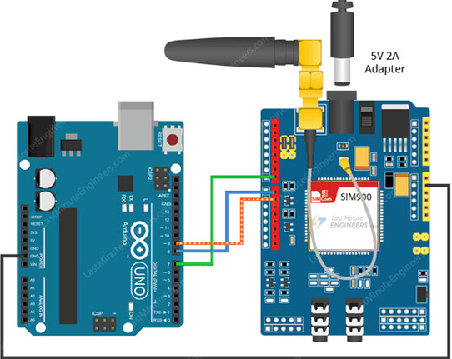

3.3. Sensory Suite
- Vision: Wide-angle optical sensor for video streaming and AI analysis.
- Audio: 8-Mic Array for 360° sound localization.
- Connectivity: Triple-channel redundancy — Wi-Fi (Telemetry), Internet API (Telegram Bot), and GSM (Emergency Backup).

3.4. Industrial Design & CAD Engineering
The visual identity and mechanical structure of NEMO were developed using professional-grade PLM software to ensure precision and structural integrity.
- Software Stack: The entire project was modeled using PTC Creo Parametric 9.0 (Educational Edition).
- Design Concept: The aesthetic of the robot is a tribute to the cinematic design seen in the film "The Lightning Code". While the visual concept was inspired by these references, the engineering execution was performed independently.
- Modeling Process: Every component was modeled from scratch based on photographic analysis. This involved creating individual part files (.prt) for the chassis, internal brackets, and the pan-tilt head mechanism. These were then integrated into a complex global assembly (.asm).
- Engineering Considerations: * Hardware Integration: Specific internal cutouts and mounting points were designed to house the Raspberry Pi 4, Arduino Uno, and the 3-wheel motor system.
  - Prototyping: The model accounts for the exact dimensions of the JGA25 motors and sensor offsets, ensuring that the physical assembly matches the digital twin without mechanical interference.
  - Scalability: The design includes modular mounts for the upcoming Lidar integration, allowing for future hardware upgrades without structural changes.
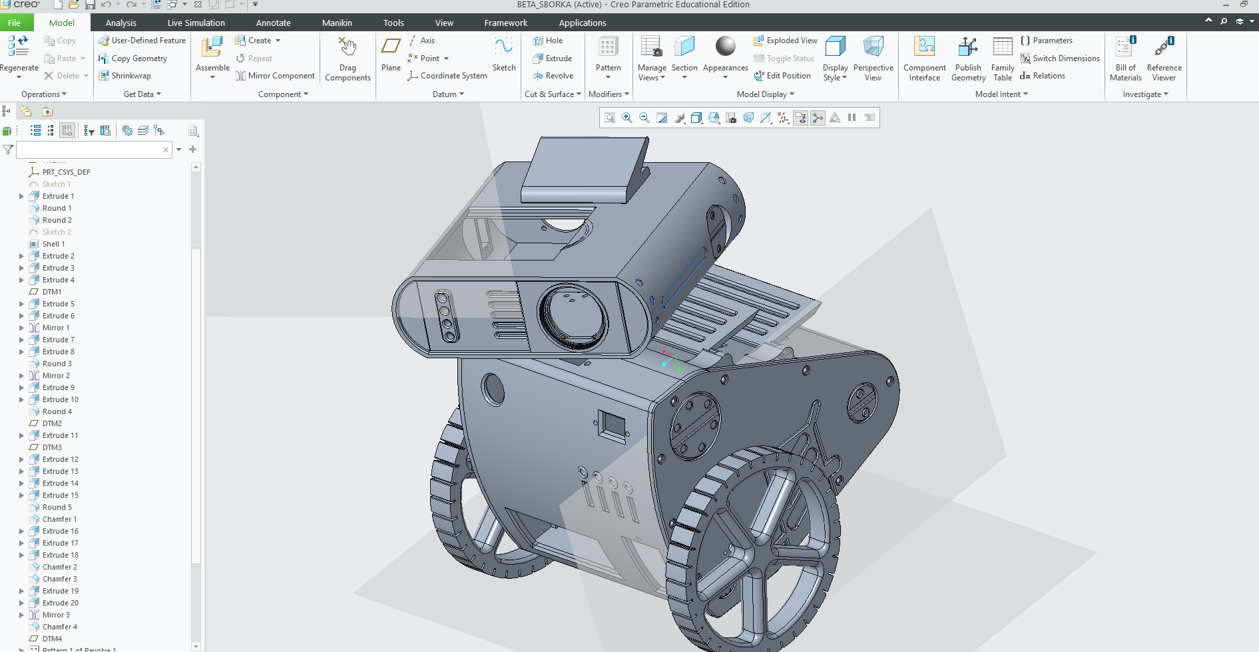
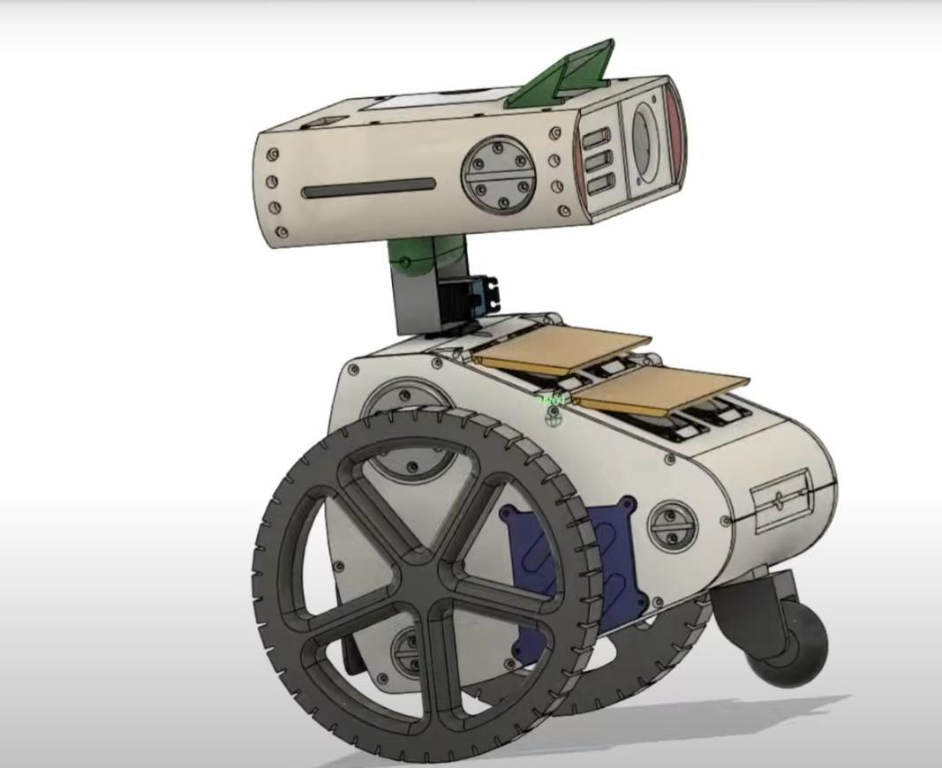
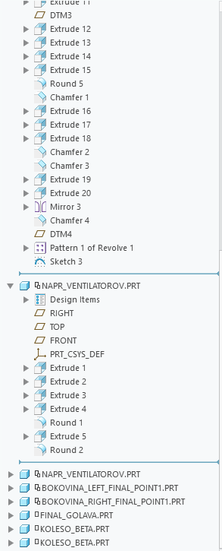

4. SOFTWARE STACK & IMPLEMENTATION

4.1. Hybrid Intelligence Pipeline (LiveKit + Gemini)
To overcome the limitations of local edge computing, the project implements a low-latency data pipeline:
- Ingest: The robot captures video and audio streams via WebRTC (LiveKit).
- Process: The Cloud Server analyzes frames using Gemini 1.5 Pro.
- Analyze: The AI determines context (e.g., "Subject detected on floor," "Signs of distress," "Hand wave gesture").
- React: The server transmits structured commands back to the Raspberry Pi to trigger hardware responses.

4.2. Multi-Channel Alert Logic (Telegram + GSM)
We implemented an Escalation Protocol to avoid false alarms and ensure information delivery.
- Level 1: Pre-Warning (Telegram API). If the AI detects an anomaly (e.g., prolonged inactivity or "strange state"), the Python script captures a snapshot and sends it to a private Telegram group via Bot API.
  - Message content: Photo of the scene + AI assessment text (e.g., "Attention: User has been lying on the sofa for 4 hours").
- Level 2: Critical Alert (Hardware Control). If the AI detects a verified fall or receives no response after the Level 1 warning, the system escalates to a hardware trigger.

4.3. Hardware Control Logic (The Serial Bridge)
This component is the core of the "Hardware Control" category entry. A custom Python driver on the Raspberry Pi translates AI intents into byte-code for the Arduino.
- Logic Flow: AI_Critical_Event → Python Script → Serial Write (b'CALL_SOS') → Arduino Interrupt → GSM Module Activation
This direct hardware bridge ensures that safety-critical features operate with minimal latency even if internet services are disrupted.
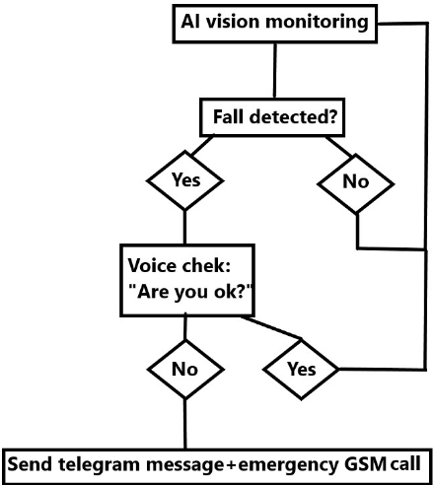

5. CURRENT CAPABILITIES vs. ROADMAP
The development of NEMO follows a strict engineering roadmap to ensure reliability and scalability.

Phase 1: The "Digital Guardian" (Current / MVP Status)
- Remote Telepresence: Relatives or medical personnel can remotely control the robot ("Mobile Avatar" mode) to inspect the premises.
- Smart Notifications: Automated Telegram alerts with photo evidence of the user's status.
- GSM Safety Net: Autonomous emergency calls triggered by critical AI analysis.
- Social Interaction: Voice dialogue and head movements driven by LLM context.

Phase 2: Autonomous Patrolling (In Development)
We are currently integrating the ROS 2 (Robot Operating System) Navigation Stack to enable full autonomy.
- Sensor Fusion: Combining data from Wheel Odometry (encoders) and Lidar (RPLidar A1).
- SLAM: Implementation of Gmapping or Cartographer algorithms for static map generation.
- Nav2 Stack: Enabling dynamic path planning for scheduled patrolling (e.g., Kitchen to Bedroom), with real-time obstacle avoidance.
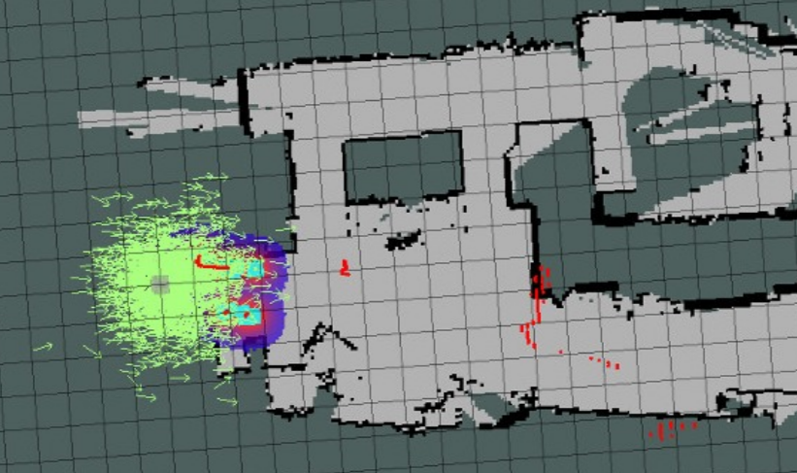
Note: The hardware interfaces and software nodes for Lidar integration are already architected into the current build.

6. INNOVATION & SOCIAL VALUE
- Cost Efficiency: By offloading computation to the cloud, the project avoids expensive hardware (e.g., Jetson Nano), making the device affordable for pension-level incomes.
- Privacy by Design: Video is processed securely; raw footage is not stored permanently.
- Active Safety: Unlike a static camera, NEMO physically moves to verify the status of a silent user, eliminating "blind spots."

7. CONCLUSION
NEMO demonstrates that effective Hardware Control is achieved through the intelligent orchestration of disparate systems. By bridging a robust Arduino-controlled chassis with the scalable power of Cloud AI and modern messaging APIs (Telegram), we have created a life-saving device that addresses one of the most pressing demographic challenges of the 21st century.

8. REFERENCES & TECH STACK
- Languages: Python (High-level logic), C++ (Firmware).
- Frameworks: ROS 2, MediaPipe, LiveKit, Telegram Bot API.
- Hardware: Raspberry Pi 4, Arduino Uno, SIM800L Module, JGA25 Motors.

